Pin Walk Info

Location Themed Pins: These pins will allow participants to earn pins from diverse walks closer to home. There is also a pin for attending an educational class on Wellness. Feel free to see what the state of Connecticut has to offer. Do a walk, run, bike ride, etc. Send an e-mail to chaslynns@soct.org with your story, pictures and the number of participants. Contact your club leader to receive your pins!


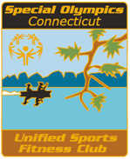
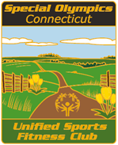
Meadow Lakeshore Indoor



Road Race Mall Bike Path

